**Beep Module Description Document**

**1.Introduction**

The AP80 series chip Beep module is a hardware module that generates sine wave signals based on software configuration.

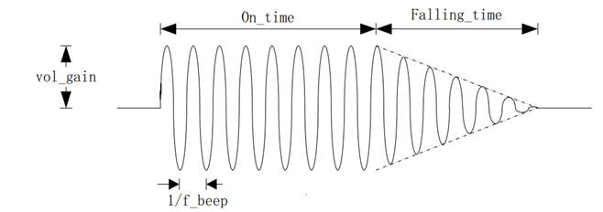

Figure 1 Beep waveform diagram

The parameters that customers can set include: the frequency of the beep sound, volume gain, duration, and fade time. It should be noted that this module is not automatically generated by hardware and is related to the current DAC/I2S sampling. Before configuration, it is necessary to obtain the sampling rate of the output channel and reconfigure it; otherwise, there may be deviations in the output frequency.

**2.Typical applications**

252 **uint32_t** SampleRateTmp;

253 SampleRateTmp = DacAdcSampleRateGet();

254 **if**(0 == SampleRateTmp)

255 {

256     SampleRateTmp = 44100;

257 }

258 BeepStart(3200, 147, SampleRateTmp, 25, 10);